"Shape Of You"_ ED SHEERAN
Task 1: Fill in the gaps with the words in the box below:
Start Dance Best Trust Shots Bar Jukebox
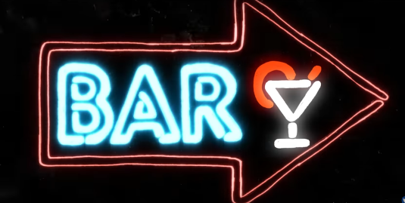
The club isn't the _____________________ place to find a lover
So the _____________________ is where I go
Me and my friends at the table doing _____________________
Drinking fast and then we talk slow (mmmm)
You come over and _____________________up a conversation with just me
And _____________________me I'll give it a chance now
Take my hand, stop
Put Van The Man on the _____________________
And then we start to _____________________
And now I'm singing like
Task 2: Pre-Chorus: Match the sentence halves:
- Girl, you know I want your love | - Grab on my waist and put that body on me
- Come on now, follow my lead | - I may be crazy, don't mind me
- Say, boy, let's not talk too much | - Your love was handmade for somebody like me
- Come on now, follow my lead | - Come, come on now, follow my lead (mmmm)
Fill in the gaps: CHORUS:
I'm in love with the shape of you
We push and _____________________ like a magnet do
Although my heart is falling too
I'm in love with your _____________________
And last night you were in my _____________________
And now my bedsheets _____________________like you
Every day _____________________something brand new
I'm in love with your body
Oh I oh I oh I oh I
x3
I'm in love with your body
Every day _____________________something brand new
I'm in love with the shape of you
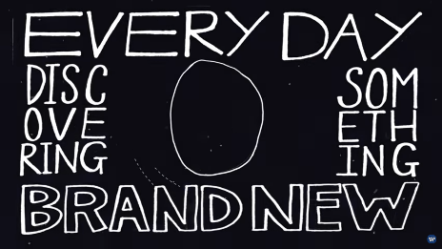
One week in we let the story _____________________
We're going out on our first _____________________ (mmmm)
You and me are thrifty
So go all you can eat
Fill up your bag and I fill up a _____________________
We talk for hours and hours about the sweet and the _____________________
And how your family is doing okay
Leave and get in a taxi, then _____________________in the backseat
Tell the driver _____________________the radio play
And I'm singing like
Pre-Chorus
CHORUS
Come on, be my baby, come on x8
CHORUS

