"Cold Water"
(feat. Justin Bieber & MØ)
Choose the correct alternative

Everybody gets high/by/fried sometimes, you know
What else can we do when we're kneeling/feeling/dealing low?
So take a deep breath/death and let it go
You shouldn't be frowning/counting/drowning on your own
(chorus) Put the lines in the right order
a._______And although time may take us into different places
b._______I won't let go
c._______And I hope you know
d._______I will still be patient with you
e._______I'll be your lifeline tonight
f._______I won't let go
g._______I will jump right over into cold, cold water for you
h._______I'll be your lifeline tonight
i._______And if you feel you're sinking,
Use the pictures to help you complete the blanks
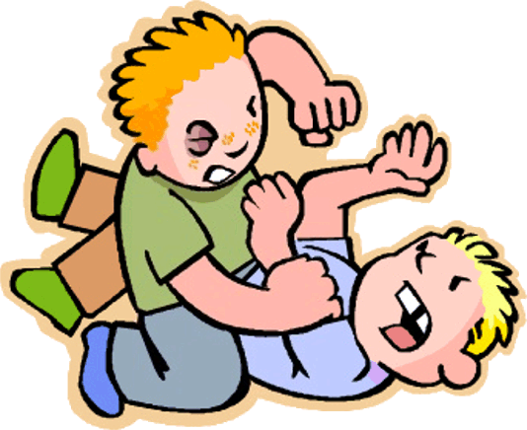

Cause we all get (1)___________________ sometimes, you know?
It's how we (2)_________________ and how we (3)________________
And I wanna lay with you 'til I'm (4)__________________
You shouldn't be (5)__________________ on your own
chorus
Each line contains a mistake, find it and correct it

- Come on, dance on
- Save me from my sinking boat
- I just want to stand afloat
- I'm all gone
- And I hope, I will
- Someone's going to take me home
- Somewhere I can find my soul
- I want to know
- I won't let go (I won't let go, no, no, no, no, no, no)
- I'll be your date tonight
- You won't let Moe
- I'll be your lifeline right
- We won't let go
- I won't be go

"Cold Water"
(feat. Justin Bieber & MØ)
[Justin Bieber:]
Everybody gets high sometimes, you know
What else can we do when we're feeling low?
So take a deep breath and let it go
You shouldn't be drowning on your own
And if you feel you're sinking,
I will jump right over into cold, cold water for you
And although time may take us into different places
I will still be patient with you
And I hope you know
I won't let go
I'll be your lifeline tonight
I won't let go
I'll be your lifeline tonight
Cause we all get lost sometimes, you know?
It's how we learn and how we grow
And I wanna lay with you 'til I'm old
You shouldn't be fighting on your own
And if you feel you're sinking,
I will jump right over into cold, cold water for you
And although time may take us into different places
I will still be patient with you
And I hope you know
I won't let go (I won't let go, no, no, no, no, no, no)
I'll be your lifeline tonight
I won't let go
I'll be your lifeline tonight
[MØ:]
Come on, come on
Save me from my rocking boat
I just want to stay afloat
I'm all alone
And I hope, I hope
Someone's gonna take me home
Somewhere I can rest my soul
I need to know
[Justin Bieber & MØ:]
You won't let go (I won't let go, no, no, no, no, no, no)
I'll be your lifeline tonight
You won't let go
I'll be your lifeline tonight
[Justin Bieber:]
I won't let go
I won't let go

https://www.youtube.com/watch?v=a59gmGkq_pw
Video with lyrics that can be used to correct the activities

