Vegetables

**Homework**

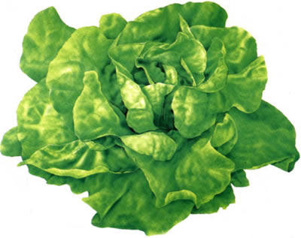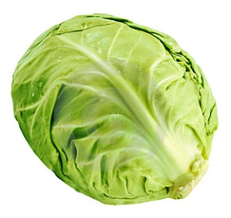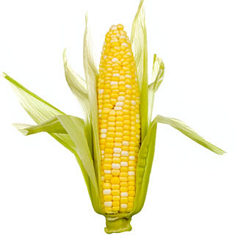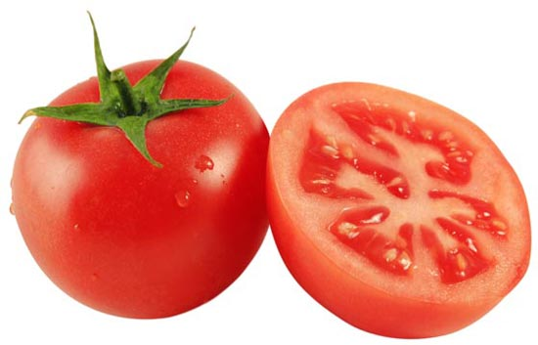

|  |  |  |  |
| --- | --- | --- | --- |
| ­­­­­­­­­­­­___________________ | ___________________ | ___________________ | ___________________ |

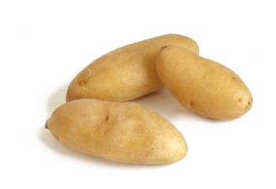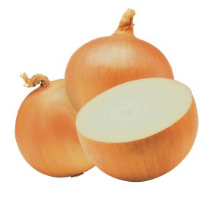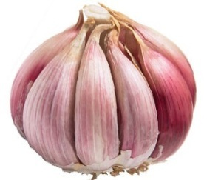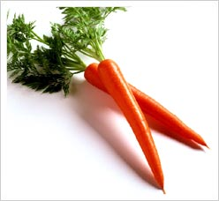

|  |  |  |  |
| --- | --- | --- | --- |
| ___________________ | ___________________ | ___________________ | ___________________ |

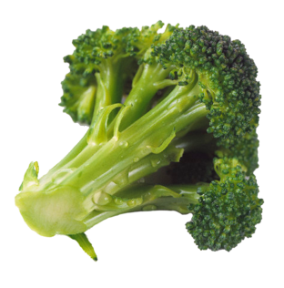 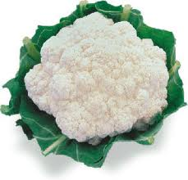 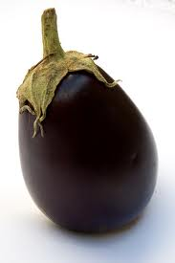 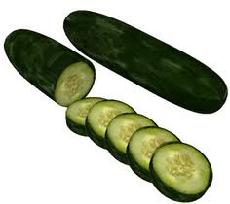

|  |  |  |  |
| --- | --- | --- | --- |
| ___________________ | ___________________ | ___________________ | ___________________ |

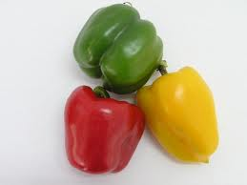 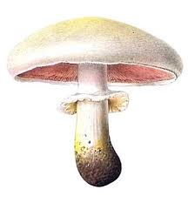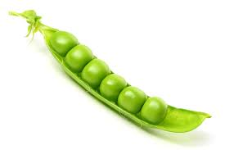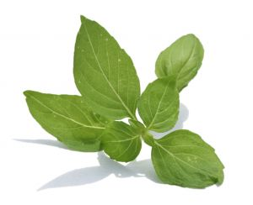

|  |  |  |  |
| --- | --- | --- | --- |
| ___________________ | ___________________ | ___________________ | ___________________ |



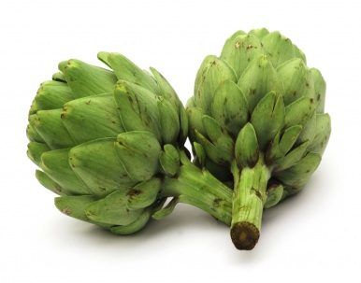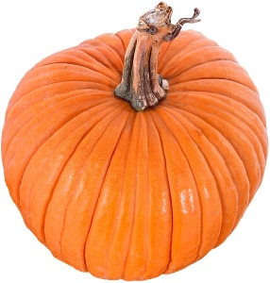 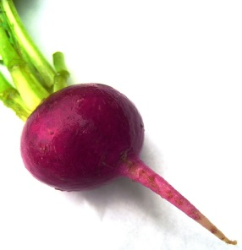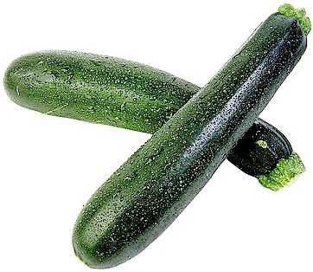

|  |  |  |  |
| --- | --- | --- | --- |
| ___________________ | ___________________ | ___________________ | ___________________ |
|  |  |  |  |

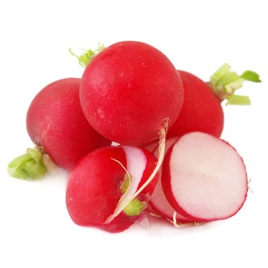 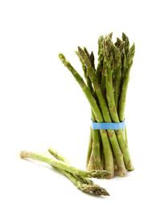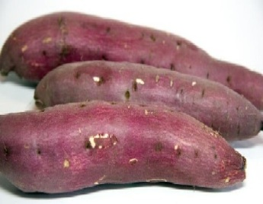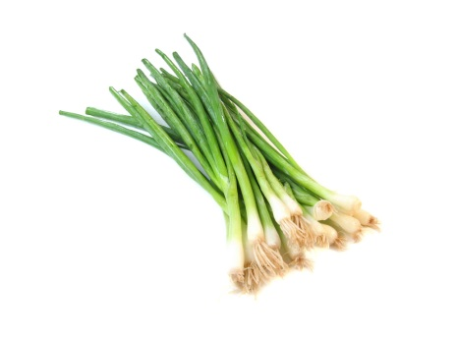

|  |  |  |  |
| --- | --- | --- | --- |
| ___________________ | ___________________ | ___________________ | ___________________ |

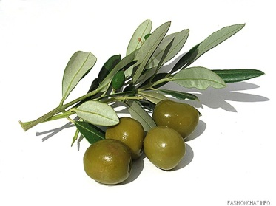 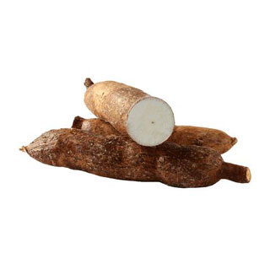 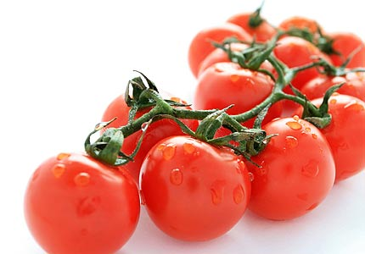 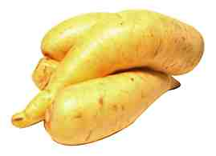

|  |  |  |  |
| --- | --- | --- | --- |
| ___________________ | ___________________ | ___________________ | ___________________ |
|  |  |  |  |

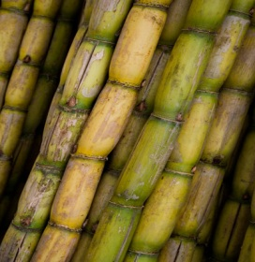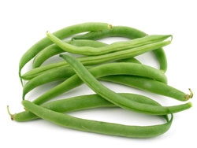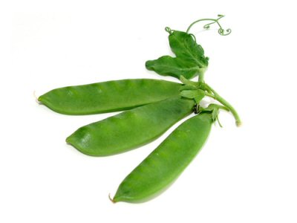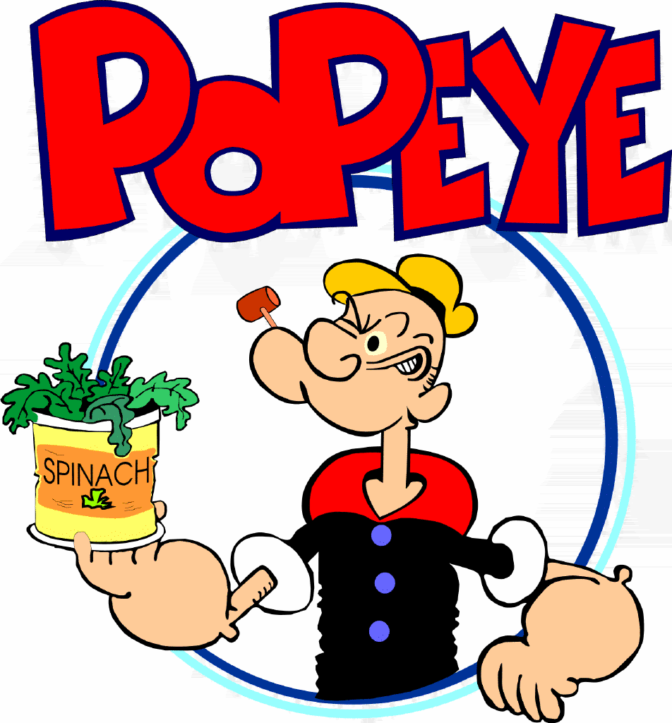

|  |  |  |  |
| --- | --- | --- | --- |
| ___________________ | ___________________ | ___________________ | ___________________ |



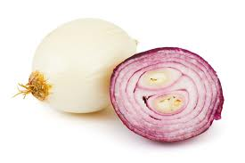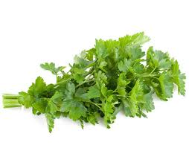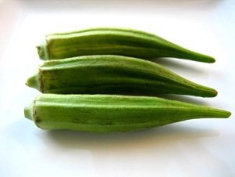 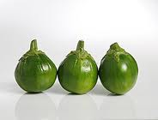

|  |  |  |  |
| --- | --- | --- | --- |
| ___________________ | ___________________ | ___________________ | ___________________ |

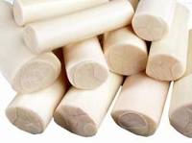 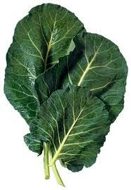 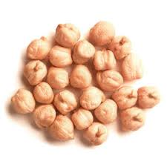 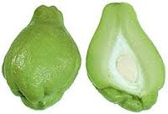

|  |  |  |  |
| --- | --- | --- | --- |
| ___________________ | ___________________ | ___________________ | ___________________ |

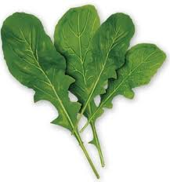 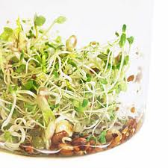 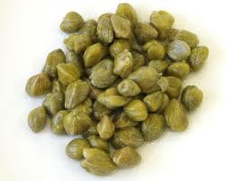 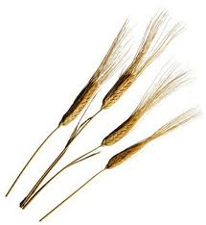

|  |  |  |  |
| --- | --- | --- | --- |
| ___________________ | ___________________ | ___________________ | ___________________ |

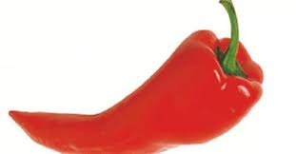 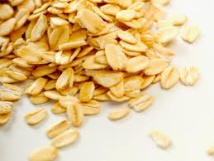

|  |  |
| --- | --- |
| ___________________ | ___________________ |



|  |
| --- |
| 1. Write the correct word into the gap. |
| |  | | --- | | http://www.englisch-hilfen.de/images/food1.jpg | |

1. __________________________________
2. __________________________________
3. __________________________________
4. __________________________________
5. __________________________________
6. __________________________________
7. __________________________________
8. __________________________________
9. __________________________________
10. __________________________________



1. Match the words to the pictures:

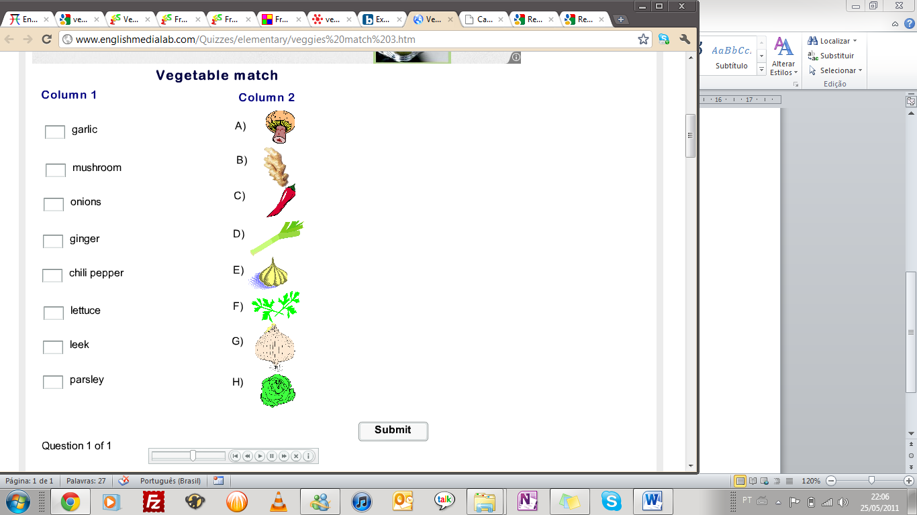

1. Put the right number into the vegetables spaces:

1.-Join the words and the pictures ,write just a number in the box

pumpkin ______________corn______________pepper______________garlic ______________cabbage______________potato______________spinach______________

mushroom______________ cauliflower______________ tomato_______________ green beans______________ broccoli ______________

olive ______________avocado______________ cucumberv asparagus ______________carrot______________

****lettuce______________ onion______________ parsley______________ zucchini______________ peas______________

1.-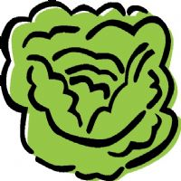2.-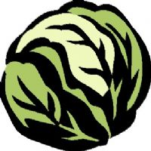3.-4.-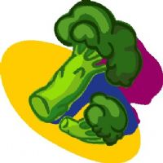 5.-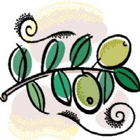6.-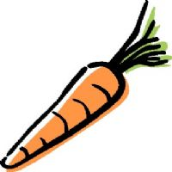7.-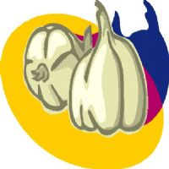8.-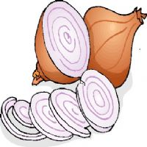

9.-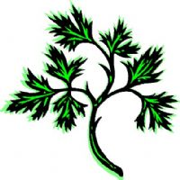10.-11.-12.-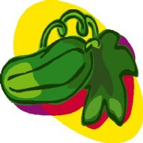

13.-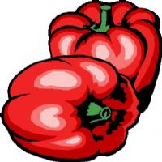14.-15.-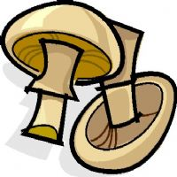16.-

17.-18.-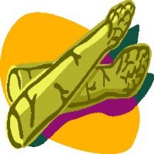19.-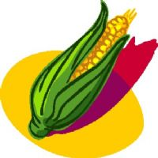20.-

21.-22.-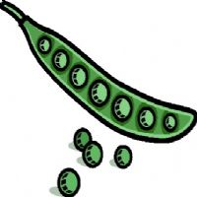23.-



1. What vegetables are these?
2. http://www.anglaisfacile.com/cgi2/myexam/images/990.gif **_____________________________________**
3. http://www.anglaisfacile.com/cgi2/myexam/images/991.gif**_____________________________________**
4. **_____________________________________**
5. http://www.anglaisfacile.com/cgi2/myexam/images/994.gif **_____________________________________**
6. http://www.anglaisfacile.com/cgi2/myexam/images/992.gif **_____________________________________**
7.  **_____________________________________**



1. http://www.anglaisfacile.com/cgi2/myexam/images/996.gif **_____________________________________**
2. http://www.anglaisfacile.com/cgi2/myexam/images/997.gif **_____________________________________**
3. http://www.anglaisfacile.com/cgi2/myexam/images/998.gif**_____________________________________**
4. http://www.anglaisfacile.com/cgi2/myexam/images/999.jpg **_____________________________________**
5. http://www.anglaisfacile.com/cgi2/myexam/images/1000.gif **_____________________________________**
6. http://www.anglaisfacile.com/cgi2/myexam/images/1001.gif **_____________________________________**



1. **_____________________________________**
2. http://www.anglaisfacile.com/cgi2/myexam/images/1003.gif **_____________________________________**
3.  **_____________________________________**