Fruit

**Homework**

1. Write the name of the fruit below:

**1. http://ns203417.ovh.net/cgi2/myexam/images/1024.gif  __________________________   
2.   __________________________   
3. __________________________   
4. http://ns203417.ovh.net/cgi2/myexam/images/1027.gif  __________________________   
5.   __________________________   
6.       __________________________   
7. __________________________   
8.   __________________________   
9.   __________________________   
10.     __________________________   
11.   __________________________**

1. Fill in the correct word:

|  |  |  |  |  |  |  |  |  |  |  |  |  |  |  |  |  |  |  |
| --- | --- | --- | --- | --- | --- | --- | --- | --- | --- | --- | --- | --- | --- | --- | --- | --- | --- | --- |
| |  |  |  |  |  |  |  |  |  |  |  |  |  |  |  |  |  |  | | --- | --- | --- | --- | --- | --- | --- | --- | --- | --- | --- | --- | --- | --- | --- | --- | --- | --- | | |  | | --- | |  | | |  |  |  | | --- | --- | --- | | http://www.learnenglish.be/voc2/fruit17.jpg | http://www.learnenglish.be/voc2/fruit2.jpg | http://www.learnenglish.be/voc2/fruit5.jpg | | 1. _____________________ | 2. _____________________ | 3. _____________________ | |  |  |  | | http://www.learnenglish.be/voc2/fruit11.jpg | http://www.learnenglish.be/voc2/fruit14.jpg | http://www.learnenglish.be/voc2/fruit8.jpg | | 4. _____________________ | 5. _____________________ | 6. _____________________ | | | |
|  |



|  |  |  |
| --- | --- | --- |
| http://www.learnenglish.be/voc2/fruit16.jpg | http://www.learnenglish.be/voc2/fruit13.jpg | http://www.learnenglish.be/voc2/fruit7.jpg |
| 1. _____________________ | 2. _____________________ | 3. _____________________ |
|  |  |  |
| http://www.learnenglish.be/voc2/fruit10.jpg | http://www.learnenglish.be/voc2/fruit4.jpg | http://www.learnenglish.be/voc2/fruit1.jpg |
| 4. _____________________ | 5. _____________________ | 6. _____________________ |

|  |  |  |  |  |  |  |  |  |  |  |  |  |  |  |  |  |  |  |
| --- | --- | --- | --- | --- | --- | --- | --- | --- | --- | --- | --- | --- | --- | --- | --- | --- | --- | --- |
| |  |  |  |  |  |  |  |  |  |  |  |  |  |  |  |  |  |  | | --- | --- | --- | --- | --- | --- | --- | --- | --- | --- | --- | --- | --- | --- | --- | --- | --- | --- | | |  | | --- | |  | | |  |  |  | | --- | --- | --- | | http://www.learnenglish.be/voc2/fruit9.jpg | http://www.learnenglish.be/voc2/fruit12.jpg | http://www.learnenglish.be/voc2/fruit3.jpg | | 1. _____________________ | 2. _____________________ | 3. _____________________ | |  |  |  | | http://www.learnenglish.be/voc2/fruit6.jpg | http://www.learnenglish.be/voc2/fruit18.jpg | http://www.learnenglish.be/voc2/fruit15.jpg | | 4. _____________________ | 5. _____________________ | 6. _____________________ | | | |

1. Write down the name of the fruit:

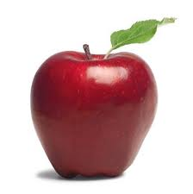 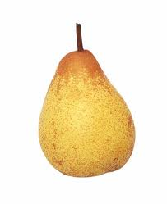 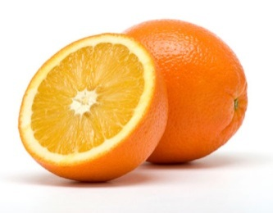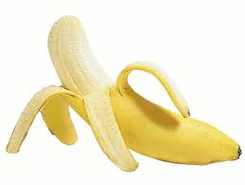

|  |  |  |  |
| --- | --- | --- | --- |
| _________________ | _________________ | _________________ | _________________ |



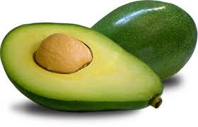 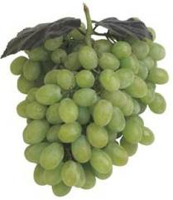 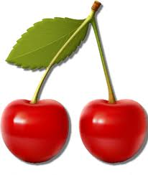 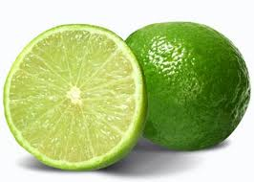

|  |  |  |  |
| --- | --- | --- | --- |
| _________________ | _________________ | _________________ | _________________ |

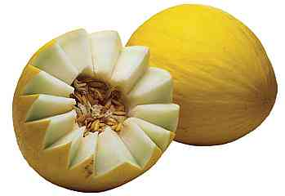 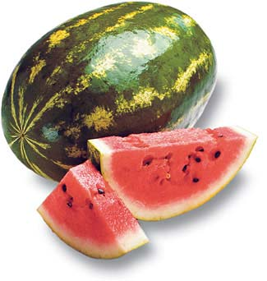 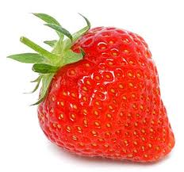 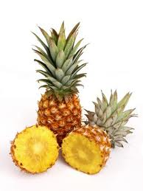

|  |  |  |  |
| --- | --- | --- | --- |
| _________________ | _________________ | _________________ | _________________ |

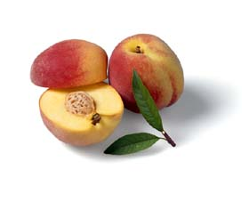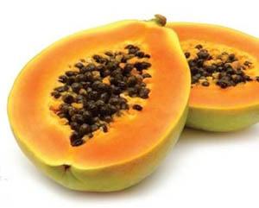 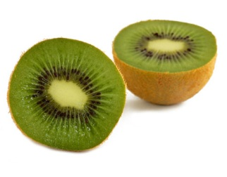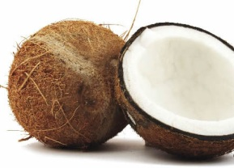

|  |  |  |  |
| --- | --- | --- | --- |
| _________________ | _________________ | _________________ | _________________ |

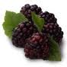 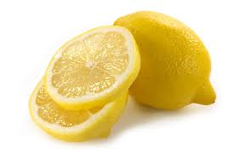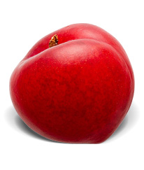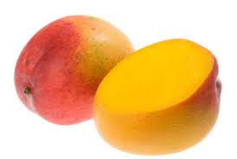

|  |  |  |  |
| --- | --- | --- | --- |
| _________________ | _________________ | _________________ | _________________ |



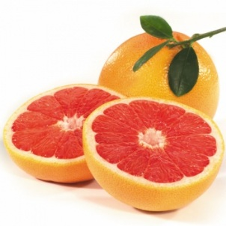 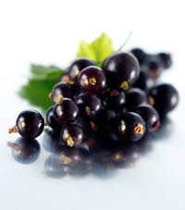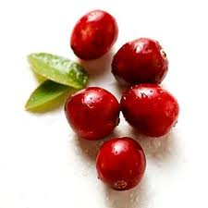 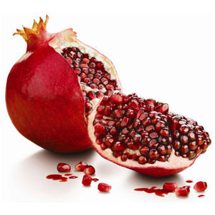

|  |  |  |  |
| --- | --- | --- | --- |
| _________________ | _________________ | _________________ | _________________ |

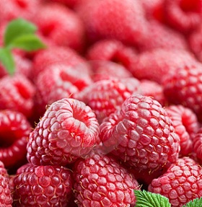 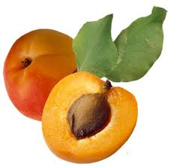 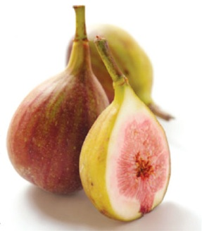 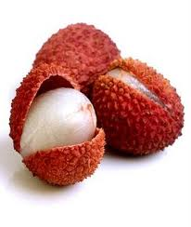

|  |  |  |  |
| --- | --- | --- | --- |
| _________________ | _________________ | _________________ | _________________ |

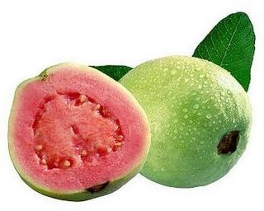 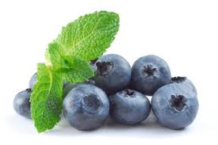 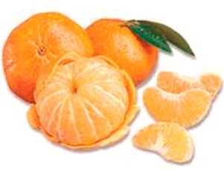 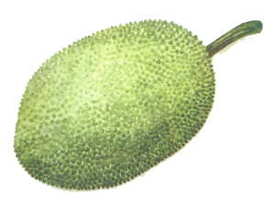

|  |  |  |  |
| --- | --- | --- | --- |
| _________________ | _________________ | _________________ | _________________ |

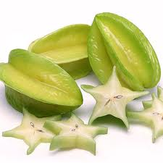 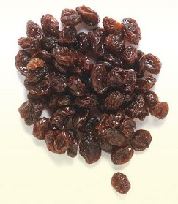 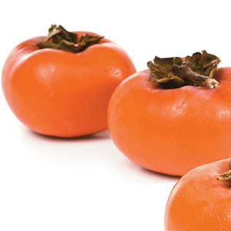 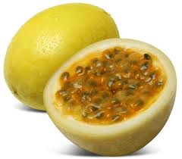

|  |  |  |  |
| --- | --- | --- | --- |
| _________________ | _________________ | _________________ | _________________ |



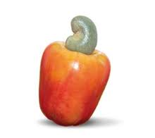

|  |  |  |  |
| --- | --- | --- | --- |
| _________________ |  |  |  |

1. Translate the senteces below:
2. Eu gosto de comer maças.
3. Meu cachorro come banana todo dia.
4. Ela não precisa comer melancia de manhã.
5. Meus pais compram lichia, manga e abacate todo final de semana.
6. Meus amigos e eu sempre comemos jaca e mirtilo.
7. Ele gosta de laranja, mas prefere mexerica.
8. Nós vendemos morango, romã, caqui e carambola aqui.
9. Eu sei que abacaxis, uvas, cerejas e melões são ótimas frutas.
10. Cereja é uma fruta muito cara.
11. Framboesa, groselha e pomelo não são frutas conhecidas.
12. ___________________________________________________________
13. ___________________________________________________________
14. ___________________________________________________________
15. ___________________________________________________________
16. ___________________________________________________________
17. ___________________________________________________________
18. ___________________________________________________________
19. ___________________________________________________________
20. ___________________________________________________________
21. ****___________________________________________________________Parte inferior do formulário