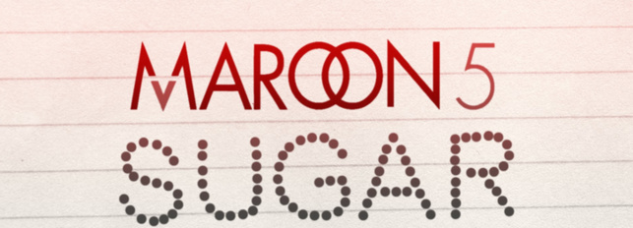

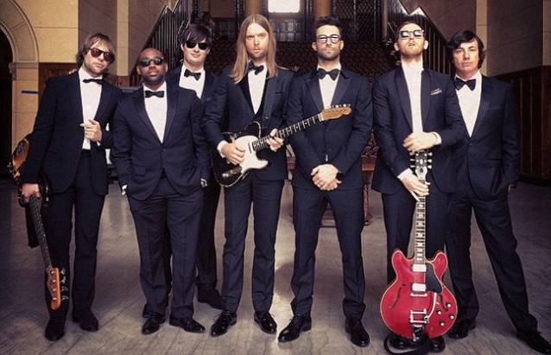

- Choose the right word:
I'm starting/hurting/hurrying baby,
I'm breaking/broken/rocking down
I need yours/your/you’re loving, loving
I need it how/know/now
When I'm about/without/in doubt you
I'm something week/wink/weak
You got me betting/begging/wedding, betting/begging/wedding
I'm on my keys/knees/news

- Fill the gaps with the words you hear:
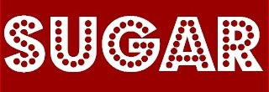
I don’t wanna be __________ your love
I just wanna be ______ in your love
And it's killing me when _______ away
Ooh ________, cause I really don't care ________ you are
I just wanna be _______ where you _____
And I gotta _____ little _______

- Fill the gaps with the antonyms of the given words::
Sugar
____ please
Won't you _____ and put it _____ on me
I'm right ______, cause I need
______ love and _______ sympathy
Yeah you ______ me ______ loving
Make it _______
Need a _______ __________ in my life
Sugar
___ please
Won't you ______ and put it _____ on me
up(x2) bad sourness
no(x2) go(x2) big(x3)
there wrong hide
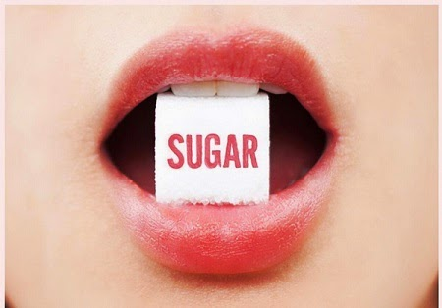
- Choose the right spelling:
My broken peaces/pieces/pisces
You peek/pik/pick them up
Don't live/leave/leeve me hanging, hanging
Come geeve/gave/give me some
When I'm witouth/without/withaut you
I’m so insecare/unsicure/insecure
You are the one tingh/thingh/thing, one tingh/thingh/thing
I'm leeving/leving/living for

- Find the mistakes and correct them:
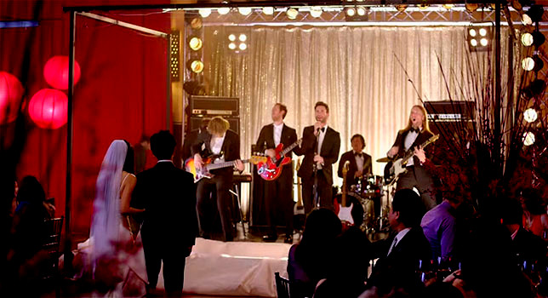
I don't wanna be bleeding your love
I just wanna be dip in your life
And it's killing me when we’re away
Ooh maybe, cause I really don't care there you are
I just wanna be here where you harm
And I gotta get a little rest
- Write the missing letters:
S_g_r
Yes pl_ _s_
W_n't you c_ _e and put it d_ _n on m_
I'm ri_ _t _ er_, c_ _se I need
L_ _tle love and l_ _tle s_mpat_ _
Yeah you s_ _ _ me g_ _ d lov_ _ _
Make it _l_i__ht
N_ _d a l_t_ _e s_e_tne_s in m_ li_e
S_g_r
Yes pl_ _s_
_ _n't y_ _ co _e and put it d_ _n on m_
- Match the lines:

Yeah , I want | (1) | ( ) a man
I want | (2) | ( ) you're hotter
Don't let | (3) | ( ) that sugar sweet
Unless that | (4) | ( ) no other way
I gotta be | (5) | ( ) that red velvet
There ain't | (6) | ( ) California day
Cause girl | (7) | ( ) all that shy shhh
than a southern | (8) | ( ) play no games
I don't wanna | (9) | ( ) somebody is me
I don't gotta | (10) | ( ) That's my…
Don't give me | (11) | ( ) nobody touch it
No make up on | (12) | ( ) be afraid

- Underline the words you hear:
Your Sugar No Yes place please Don’t Won’t your you come and pull put it up down at on me mine I'm bright right there here, cause I seek need Big Little love and sweet little sympathy So maybe baby, just chow show my me God good bad loving Take Make it right alright Need a line little sourness sweetness on in my live life Sugar Yet Yes please Don’t Won't yours you come came and put it up down of on me
(Chorus)

