Blank Space- Taylor Swift
bad | mistake | funny | see | incredible | passport
suit | been | friends | magazine | game | face
Write the correct word.
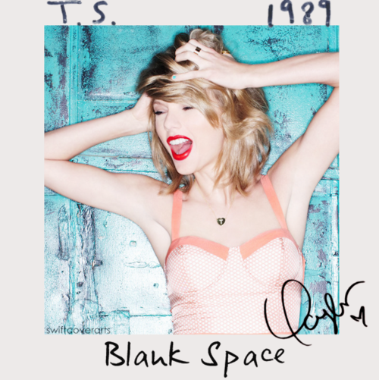
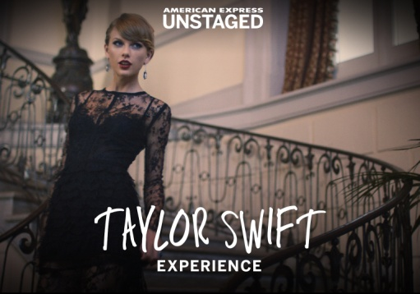
Nice to meet you
Where you ___________?
I could show you _________________ things
Magic, madness, heaven, sin
Saw you there and I thought oh my god
Look at that _____________, you look like my next ________________
Love's a ____________, wanna play
New money, ____________ and tie
I can read you like a _________________
Ain't it __________ rumors fly
And I know you heard about me
So hey, let's be _________________
I'm dying to ____________ how this one ends
Grab your _____________ and my hand
I could make the ____________ guys good for a weekend
[Pre-Chorus] Circle the correct word.
So it's gonna be freezer/ forever/ freer
Or it's gonna go down in blames/ fame/ flames
You can tell me when it's over/ oval/ overt
If the high was worth the pain/ stain/ gain
Got a long list of ex-loafers/ex-lovers/ex-liars
They'll tell you I'm in pain/ insane/ insight
Cause you know I love the players/ plays/ playing
And you love the same/fame/game
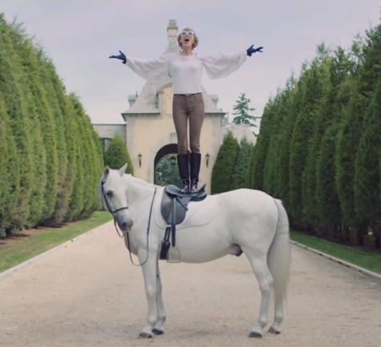
[Chorus]: Number the chorus in order 1-8.
______ Got a long list of ex-lovers
______ It'll leave you breathless
______ But I got a blank space baby
______ Cause we're young and we're reckless
______ Or with a nasty scar
______ And I'll write your name
______ They'll tell you I'm insane
______ We'll take this way too far

worst | nightmare | leave | kisses | tables | king
she | skies | month | crying | thorns | things

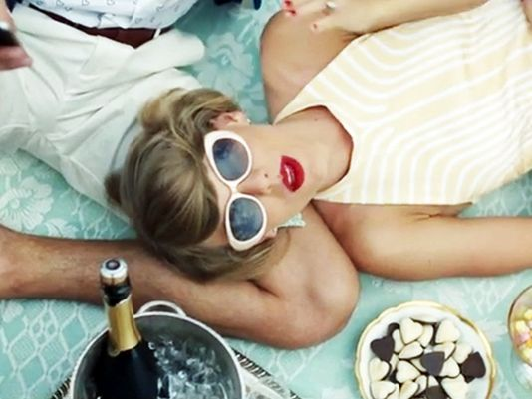
Cherry lips
Crystal ____________
I could show you incredible _______________
Stolen __________, pretty lies
You're the __________ baby I'm your queen
Find out what you want
Be that girl for a _______________
But the _____________ is yet to come Oh no
Screaming, _____________, perfect storms
I could make all the _________________ turn
Rose garden filled with _____________________
Keep you second guessing like oh my god
Who is _____________? I get drunk on jealousy
But you'll come back each time you _______________
Cause darling I'm a _________________ dressed like a daydream
[Pre-Chorus]
[Chorus]
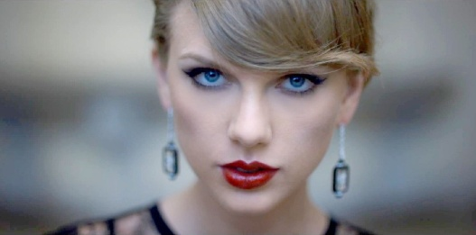
[Bridge] X2
Boys only want love if it's torture
Don't say I didn't say I didn't warn you

[Pre-Chorus]
[Chorus]

VOCABULARY MATCH
_____ rumor a. not being careful
_____ nightmare b. very bad to see, taste, smell, etc…
_____ daydream c. mentally crazy
_____ insane d. an angry feeling of wanting to have what someone else has
_____ reckless e. a very bad dream
_____ torture f. gossip
_____ jealousy g. to cause severe pain
_____ nasty h. to think good thoughts about your life or future while awake

PICTURE MATCH
_____ Passport A.
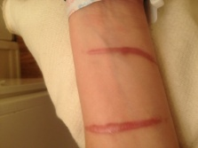
_____ scar B.

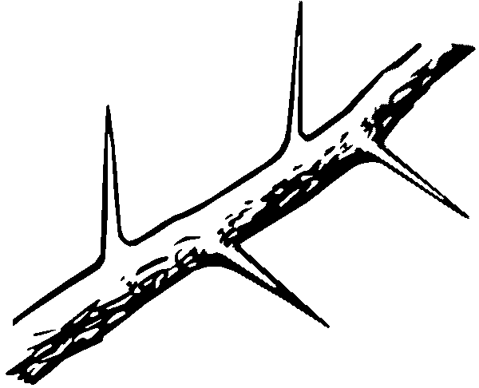
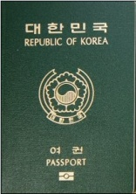
_____ thorns C.

_____ suit D.

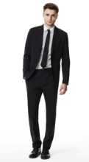
_____ flames E.

