Listen to the song and circle the word you
hear from the choice of bold pair.

Nickname: ______________________________

Living / Loving can hurt; living / loving can hurt sometimes
but it's the only / main thing that I know
and when it gets hard / hot you know it can get hard /hot sometimes
It is the only thing that helps / makes us feel alive

Chorus
We keep this thought / love in a photograph
we made these memories / pictures for us / ourselves
Where our eyes are never looking / closing
hearts are / ice is never broken
and time’s / hearts forever frozen still / solid
so you can keep / put me
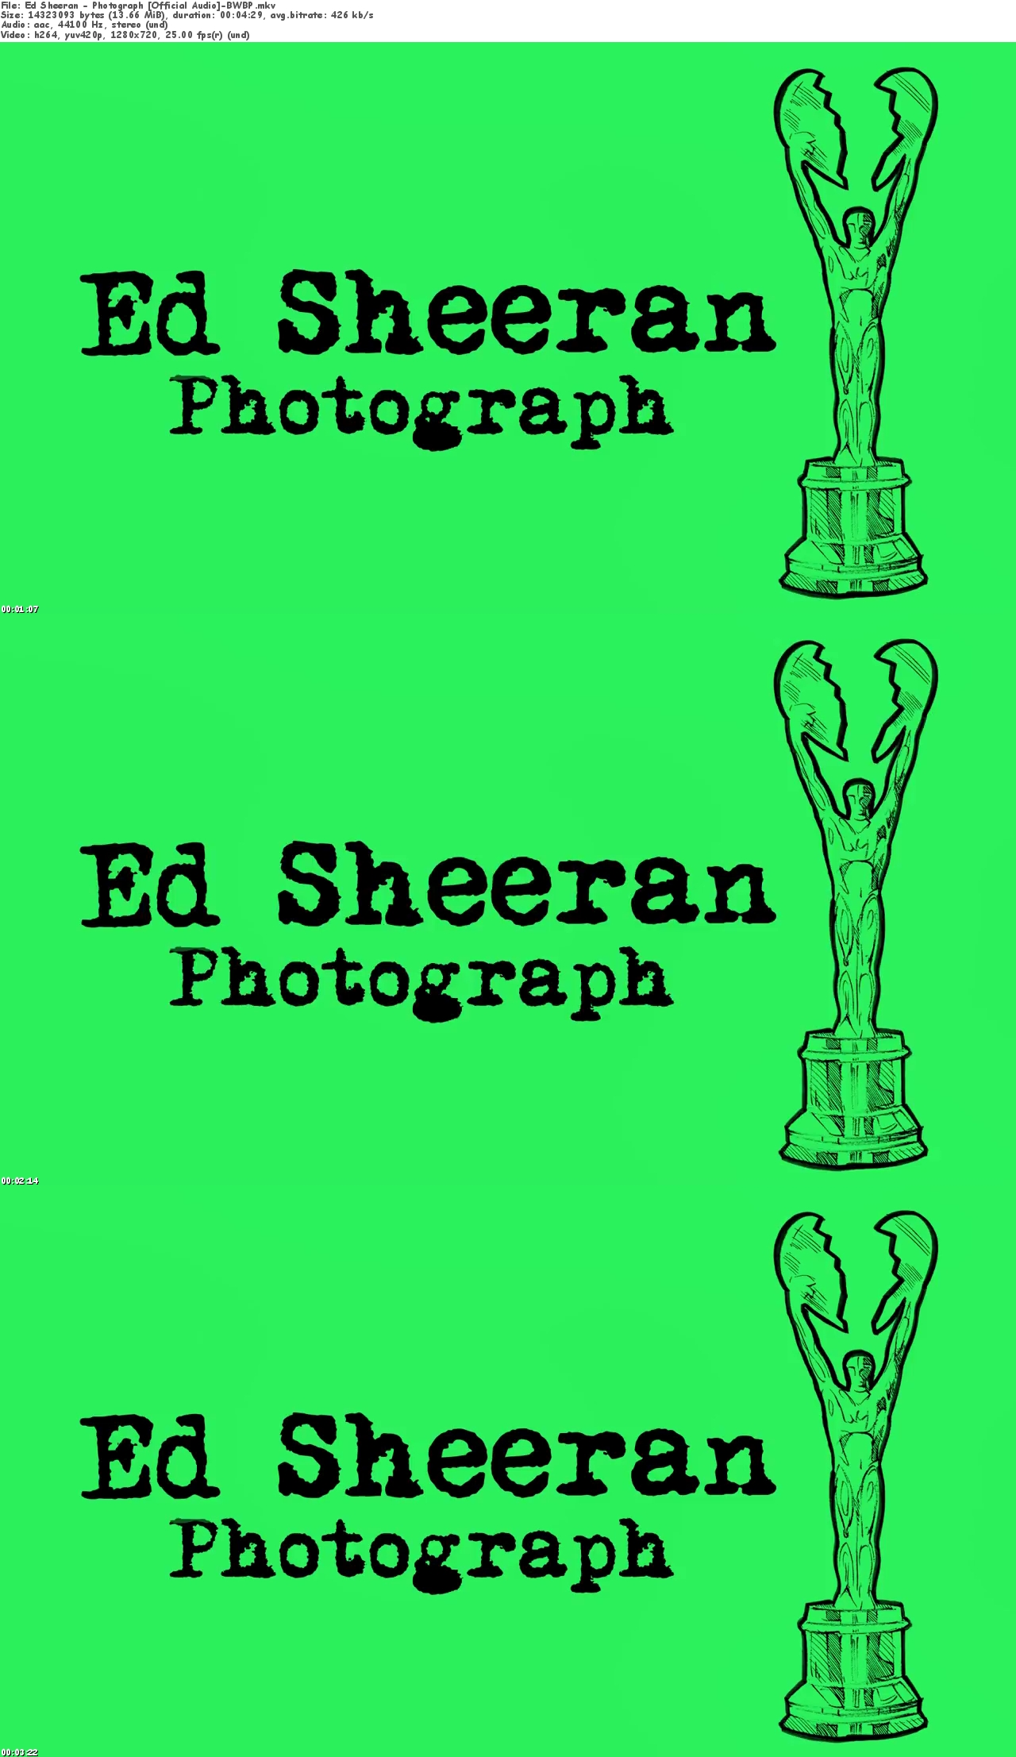
inside the pocket of your faded / ripped jeans
holdin' me closer / nearer til our eyes / lips meet
you won't ever / will never be alone
wait for me to come home

Loving can heal, / feel , loving can repair / mend your soul
and is the only / main thing that I know
I know / swear it will get easier
remember / reminder that with every piece of ya
and it's the only thing we bring / take with us when we die

Chorus

And if you leave / hurt me
well that's ok baby only noses / words bleed
inside these pages / stories you just hold me
and I won't ever / be able to let you go
wait for me to come home x 4

Oh you can fit me inside the photograph / necklace you got when you were 16
next to your heartbeat / soft skin where I should be
keep it deep / all within your soul

And if you leave / hurt me
well that's ok baby only noses / words bleed
inside these pages / stories you just hold me
and I won't ever / be able to let you go

When I'm away / gone
I will recall / remember how you missed / kissed me
under the lamppost / street light back on 6th street
hearing / heard you whisper through the wall / phone
wait for me to come home

