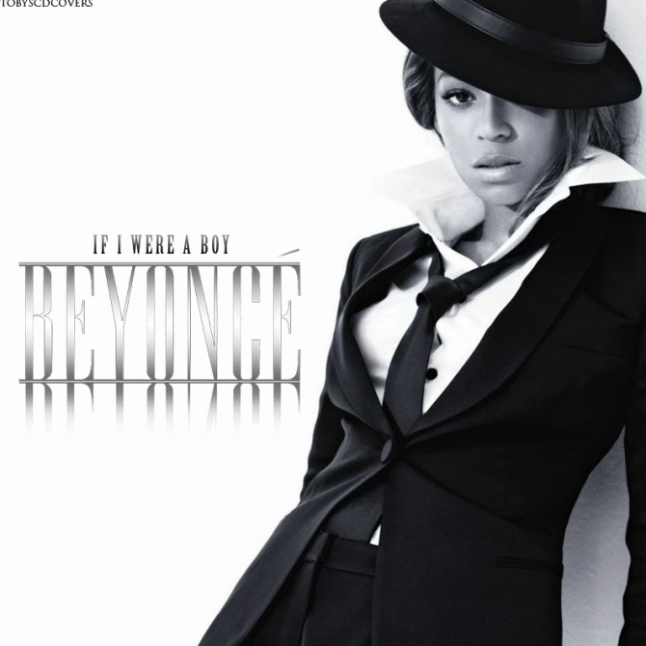
IF I WERE A BOY. (Beyonce)
If I were a boy even just for a day
I'd roll out of bed in the ___________
And throw on what I wanted and go
Drink beer with the guys
And chase after ___________
I'd kick it with who I wanted
And I'd never get confronted for it
'Cause they stick up for me
{Chorus}
If I were a boy
I think I could understand
How it feels to love a girl
I ___________I'd be a better man
I'd listen to her
'Cause I know how it hurts
When you lose the one you __________
'Cause he's taking you for granted
And everything you had got destroyed
{Verse}
If I were a boy
I would turn off my phone
Tell everyone it's broken
So they'd think that I was sleeping ____
I'd put myself first
And make the rules as I go
'Cause I know that she'd be faithful
Waiting for me to come ___________
To come home...
{Chorus}
If I were a boy
I think I could understand
How it feels to love a girl
I ___________I'd be a better man
I'd listen to her
'Cause I know how it hurts
When you lose the one you ________ (___________)
'Cause he's taking you for granted (granted)
And everything you had got destroyed
{Bridge}
It's a little too late for you to come back
Say it's just a ___________
Think I'd forgive you like that
If you thought I would wait for you
You thought wrong
{Chorus }
But you're just a boy
You don't understand
Yeah you don't understand, oh
How it feels to love a girl
Someday you wish you were a better ____
You don't listen to her
You don't care how it hurts
Until you lose the one you wanted
Cause you're taking her for granted
And everything you had got destroyed
But you're just a boy!

- Fill in the blanks.
- Try to give a definition for the expressions in bold type.
- What type of song (love, protest, etc.) is this one?
- Are there different parts in the song? Which ones? How do you know?
- What are the things she would do “if she was a boy”? List them.
- What is the message of the song? What is she trying to say? Is there anything she doesn’t like?
- What would you do if you were a boy/girl? How would your life be different?
IF I WERE A BOY. (Beyonce)
If I were a boy even just for a day
I'd roll out of bed in the morning
And throw on what I wanted and go
Drink beer with the guys
And chase after girls
I'd kick it with who I wanted
And I'd never get confronted for it
'Cause they stick up for me
{Chorus}
If I were a boy
I think I could understand
How it feels to love a girl
I swear I'd be a better man
I'd listen to her
'Cause I know how it hurts
When you lose the one you wanted
'Cause he's taking you for granted
And everything you had got destroyed
{Verse}
If I were a boy
I would turn off my phone
Tell everyone it's broken
So they'd think that I was sleeping alone
I'd put myself first
And make the rules as I go
'Cause I know that she'd be faithful
Waiting for me to come home
To come home...
{Chorus}
If I were a boy
I think I could understand
How it feels to love a girl
I swear I'd be a better man
I'd listen to her
'Cause I know how it hurts
When you lose the one you wanted (wanted)
'Cause he's taking you for granted (granted)
And everything you had got destroyed
{Bridge}
It's a little too late for you to come back
Say it's just a mistake
Think I'd forgive you like that
If you thought I would wait for you
You thought wrong
{Chorus }
But you're just a boy
You don't understand
Yeah you don't understand, oh
How it feels to love a girl
Someday you wish you were a better man
You don't listen to her
You don't care how it hurts
Until you lose the one you wanted
Cause you're taking her for granted
And everything you had got destroyed
But you're just a boy!

- Fill in the blanks.
- Try to give a definition for the expressions in bold type.
- What type of song (love, protest, etc.) is this one?
- Are there different parts in the song? Which ones? How do you know?
- What are the things she would do “if she was a boy”? List them.
- What is the message of the song? What is she trying to say? Is there anything she doesn’t like?
- What would you do if you were a boy/girl? How would your life be different?

